**SPRINT 3**

|  |  |
| --- | --- |
| TEAM ID | PNT2022TMID51155 |
| PROJECT NAME | SMART FASHION RECOMMENDER APPLICATION |

**INTEGRATING CHATBOT WITH HTML PAGE (SOURCE CODE)**

<script>

Window.watsonAssisstantChatOptions

=

{ integrationID: "614a4315-ff80-4187- 8fe4-2fd9b506b723", //

The ID of this integration. region: "au- syd", // The region your integration is hosted in.

serviceInstanceID: "9670dcf8- 789f-4609-8d7a-6e25c412a9ec", // The ID of your service instance. onLoad: function(instance) {

instance.render(); }

}; setTimeout(function(){

const t=document.createElement('script'); t.src="https://web-

chat.global.assistant.watson.appdomain.cloud/versions/"+

(window.watsonAssistantChatOptions.clientVersion||'latest') +

"/WatsonAssistantChatEntry.js"; document.head.appendChild(t);

});

</script>

**INTEGRATING CHATBOT WITH HTML PAGE:**

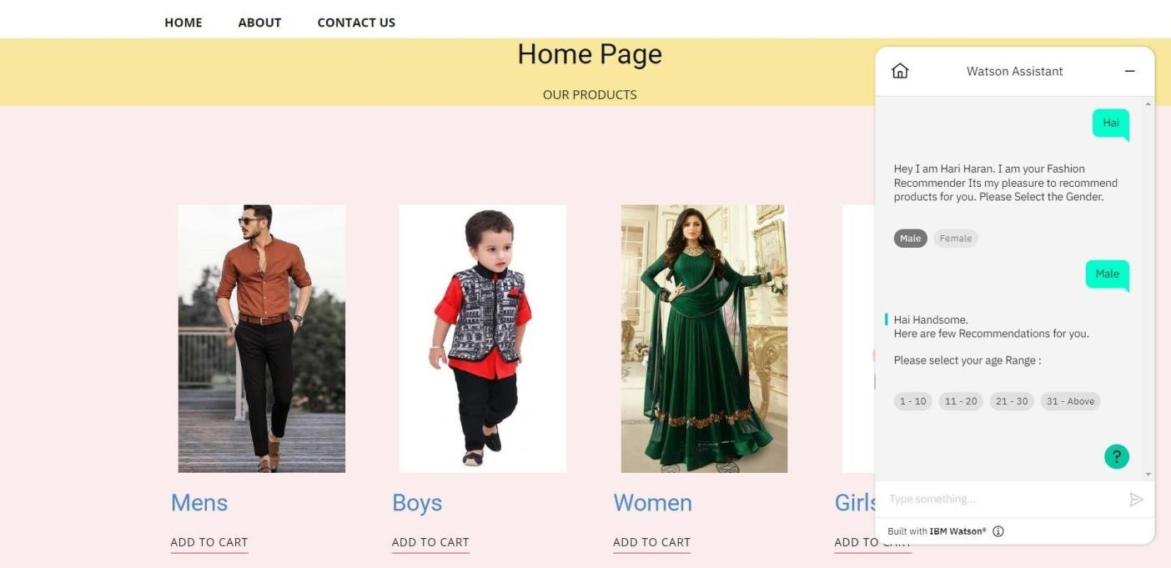

**DOCKER PUSH:**

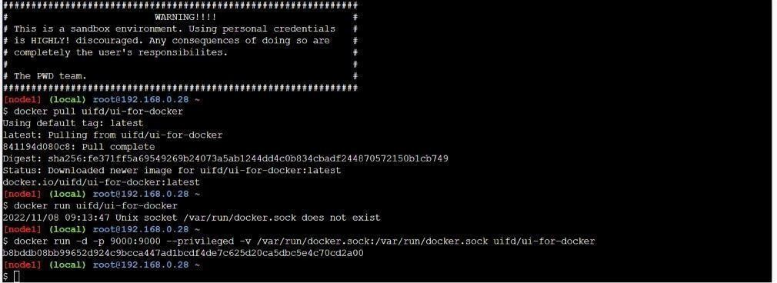

**CONTAINERIZING THE APPLICATION:**

